**DAILY ONLINE ACTIVITIES SUMMARY**

|  |  |  |  |  |  |  |  |
| --- | --- | --- | --- | --- | --- | --- | --- |
| **Date:** | **19/05/2019** | | | | **Name:** | **Syed Rabeya Aamir** | |
| **Sem & Sec** | **8th B** | | | | **USN:** | **4AL16CS112** | |
| **Online Test Summary** | | | | | | | |
| **Subject** | | **BDA** | | | | | |
| **Max. Marks** | | **30** | | **Score** | | **21** | |
| **Certification Course Summary** | | | | | | | |
| **Course** | **Introduction To Hadoop** | | | | | | |
| **Certificate Provider** | | | **Great Learning Academy** | **Duration** | | | **30 mins** |
| **Coding Challenges** | | | | | | | |
| **Problem Statement:1) To add some letters for a given word or letter then to find shortest palindrome possible.**  **2) To check whether the given linked list is palindrome or not.** | | | | | | | |
| **Status: Solved** | | | | | | | |
| **Uploaded the report in Github** | | | | **yes** | | | |
| **If yes Repository name** | | | | **rabeya** | | | |
| **Uploaded the report in slack** | | | | **yes** | | | |

**Online Test Details:**

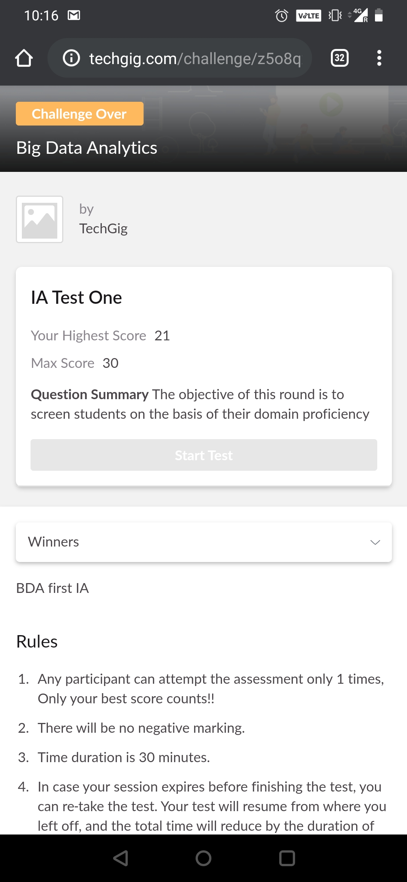

**Certification Course Details**:

**Introduction to Hadoop:-**

Apache Hadoop is a collection of open-source software utilities that facilitate using a network of many computers to solve problems involving massive amounts of data and computation. It provides a software framework for distributed storage and processing of big data using the MapReduce programming model.



**Coding Challenges Details**:

**program1:**

package shortestpalindromeexample.java;  
import java.util.Scanner;

public class ShortestPalindromeDemo {

public static String shortestPalindrome(String str) {

int x=0;  
int y=str.length()-1;

while(y>=0){  
if(str.charAt(x)==str.charAt(y)){  
x++;  
}  
y--;  
}

if(x==str.length())  
return str;

String suffix = str.substring(x);  
String prefix = new StringBuilder(suffix).reverse().toString();  
String mid = shortestPalindrome(str.substring(0, x));

return prefix+mid+suffix;  
}

public static void main(String[] args) {

Scanner in = new Scanner(System.in);

System.out.println("Enter a String to find out shortest palindrome");

String str=in.nextLine();

System.out.println("Shortest palindrome of "+str+" is "+shortestPalindrome(str));

}

**program 2**

import java.util.Stack;

class Node {  
int data;  
Node next;

Node(int i)

{

this.data = i;

this.next = null;

}

};

class Main  
{  
public static boolean isPalindrome(Node head)  
{  
// construct an empty stack  
Stack s = new Stack<>();  
Node node = head;  
while (node != null) {  
s.push(node.data);  
node = node.next;  
}

node = head;

while (node != null)

{

int top = s.pop();

if (top != node.data) {

return false;

}

node = node.next;

}

return true;

}

public static void main(String[] args)

{

Node head = new Node(1);

head.next = new Node(2);

head.next.next = new Node(3);

head.next.next.next = new Node(2);

head.next.next.next.next = new Node(1);

if (isPalindrome(head)) {

System.out.print("Linked List is a palindrome.");

} else {

System.out.print("Linked List is not a palindrome.");

}

}

}